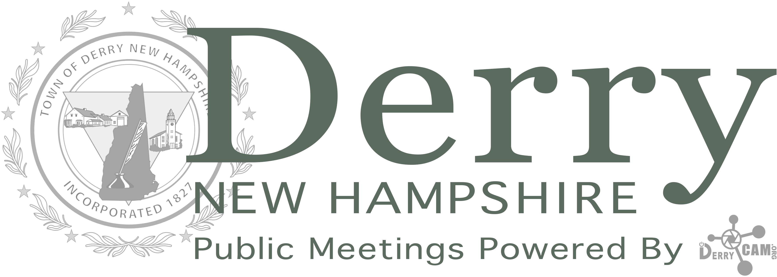

TOWN OF DERRY PUBLIC NOTICE

Virtual Meeting of the TOWN COUNCIL Scheduled

Tuesday, September 15, 2020 at 7:00 PM.
In response to the state of emergency in New Hampshire regarding COVID-19, regular public meetings of the Town of Derry will be held via remote conference call until further notice.

These virtual meetings are open remotely for attendance and participation during the public
comment/hearing portions of the meeting. To access meetings, follow the specific instructions posted within public notices for each meeting.

To attend this meeting:

Use a PC, Mac, iPad, iPhone or Android device
URL: https://zoom.us/j/889403895 Your browser may ask you to install Zoom
Enter Meeting ID: 889-403-895

By phone:
Phone numbers: 646 558 8656 or 312 626 6799 or 301 715 8592
Enter Meeting ID: 889-403-895

If you have problems calling in during a scheduled meeting time, contact 603-845-5585
or email
danielhealey@derrynh.org

Meetings will be broadcast Live on DerryTV (Comcast Ch.17) and available OnDemand by visiting derrycam.org/tune-in

