New Transfer Station Guidelines
As of January 5, 2016, Derry residents will be utilizing the new Transfer Station
for most household waste items. With the new station comes new regulations on segregating materials at drop-off.
When bringing trash and recyclables, the new categories are:
• Household Trash
• Cardboard
o Corrugated Cardboard Boxes
• Mixed Paper
o Junk mail, newspaper, magazines
• #1 Plastics – PETE
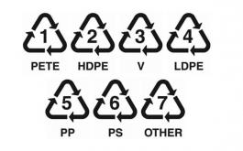
o Soft drink, water bottles, mouthwash bottles, peanut butter
• #2 Plastics – HDPE
o Milk jugs, detergents, shampoo, cereal box liners
• Steel/Tin Cans
o Food Packaging
• Aluminum Cans
o Soft drinks, beer cans
• #3-#7 Plastics
o All other plastics including plastic cups, yogurt containers, salad dressing bottles
• Glass
o Bottles, Jars (This does NOT include light bulbs)

Each category will have its own disposal bay at the Transfer Station. These bays are marked accordingly.
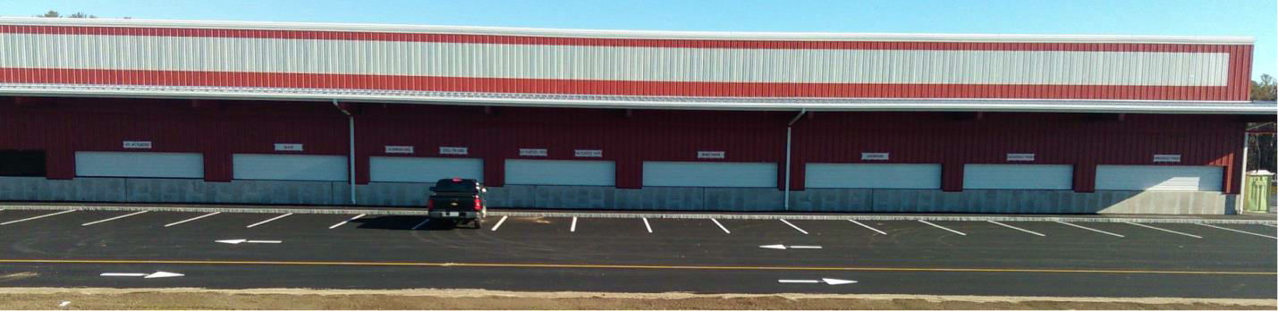

Page 1

Fees will still be imposed on the following:
• Construction and Demolition Debris
• Computers and Television Monitors
• Air Conditioners
• Tires
• Bulky Furniture including Couches and Mattresses

The following materials will still be accepted without fees:
• Metals
• Yard Waste
• Christmas Trees
• Brush – No Contractors
• Propane Tanks
• Batteries
• Waste Oil
• Fluorescent Light Bulbs

For questions or concerns, please call the Derry Transfer Station at (603) 432-6750 between Tuesday and Saturday, 6:00AM to 3:30PM.

Page 2

